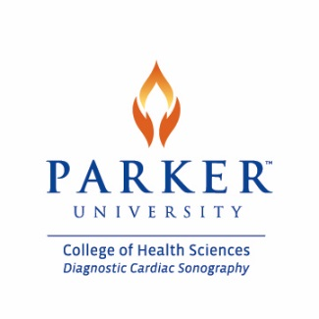
Technical Standards
In addition to academic and performance standards students must be able to meet and maintain the following technical standards for the purpose of admission and continuation in the program. Please read the following standards carefully, make an assessment of your capabilities and determine if you have any limitations that may restrict or interfere with your satisfactory performance of any of the standards listed below.

- Communicate Effectively- Ability to interact with patients and healthcare professionals in both written and verbal form. Be able to articulate in a clear and distinct manner procedures, instructions and oral reports
- Cognitive- Ability to execute complex mental processes. Obtain and retain didactic knowledge including many procedures and protocols with the ability to apply this knowledge for the purpose of collecting, interpreting, and integrating information to make examination related decisions. Utilize problem solving skills while performing sonographic procedures to establish the best diagnostic information possible.
- Coordination- Gross body coordination such as maintain balance, hand-eye coordination, arm-hand steadiness and precision. Dexterity to operate control panel while manipulating transducer simultaneously.
- Visual and Hearing- ability to distinguish color on Doppler procedures as well as various shades of graph while performing sonograms. Hearing must be adequate to perceive and interpret equipment signals, monitor alarms, and calls for help.
- Stamina- Ability to push/pull objects in excess of fifty (50) pounds. Ability to stand during examinations and long procedures. Lift and transfer patients from wheelchair or stretcher to and from examination table. Assist patients into proper position for examination.
- Emotional Stability- Ability to adapt and function under stress. Deal with the unexpected and adapt to change. Perform multiple tasks and responsibilities concurrently. Possess a strong work ethic, compassion and integrity.

I have read and understand I am subject to dismissal if after admission to the Diagnostic Cardiac Sonography Program it is discovered that I cannot meet the technical standards listed above. I hereby acknowledge the consequence of the above disclosure.

_____________________________
Prospective Student Name (print)
_____________________________ ____________
Prospective Student Signature Date

